Email: bexleynth-p.school@det.nsw.edu.au
Web Address: www.bexleynthp.schools.nsw.edu.au

YEAR 4 EXCURSION TO BERRY SPORTS & RECREATION CENTRE

Dear Parents/Carers,

Year 4 will be attending an overnight excursion to Berry Sports and Recreation Centre. The program that the students will be participating in is ‘ROAR’. This delivers outstanding and dynamic learning that stimulates and motivates students while complementing the curriculum. Students take part in fun group challenges and activities that promote key learning through:
• Relationships - developing skills in communication, problem solving, cooperation, negotiation, respect and care
• Outdoors – nurturing an appreciation of the natural environment and sustainability
• Action – reinforcing the importance of physical activity for wellbeing
• Resilience –collaborating, negotiating and reflecting on difficult challenges to build courage and strength.

DATE: The Year 4 Excursion to Berry is next term,
Monday 20 and Tuesday 21 May, 2019

WHERE: Berry Sports and Recreation Centre

COST: $240.00 fully inclusive (including travel, meals and accommodation)
The remaining balance for the camp after the $100 deposit can be paid by instalments, as follows:
1st instalment: $70 by Friday 22 March
2nd instalment: $70 by Friday 12 April

MEDICAL & DIETARY INFORMATION:

Please complete all medical and consent details below and return it to your class teacher by Friday 29 March.

In addition, attached is the Berry Sports and Recreation excursion information note that requires parents/carers to complete online. This includes: medical conditions, food related allergies, special diets, medication, emergency contact details and media consent.

WHAT TO BRING:
Your child should start to think about what they will need for this excursion.

The packing checklist is as follows:
- 1 pair of jeans/long pants
- Shorts/t-shirts
- Jumper and tracksuit pants (it will be cold)
- Warm jacket
- Socks and underwear
- Raincoat
- Pyjamas
- Comfortable walking shoes/joggers
- Handkerchief or tissues
- Water bottle
- Toiletries, including soap (no aerosols)
- Plastic bags for dirty clothes
- Medications (if required)

Please label clothing and all belongings with your child’s name.

Students can bring a camera and a small amount of money to buy something to eat on the way home.

WHAT NOT TO BRING:
Radios or MP3 players, computer/video games, mobile phones, lollies or chewing gum, jewellery or anything valuable.

MEALS:
All other meals will be supplied the Berry Sports and Recreation Centre.

EXPECTATIONS:
Please note that to ensure the safety and happiness of all who attend, we will only take students on this excursion who consistently demonstrate that they follow the school rules and show respect to all their teachers and peers.

Should you have any questions regarding the planned excursion, please speak to your child’s class teacher as soon as possible.

Mrs A. Sheinwald Mrs M. Bajic
Principal Stage Two Supervisor

STAGE 2, BERRY CAMP PERMISSION NOTE

I give permission for my child ______________________________________ in class __________ to travel to and from Berry and participate in the events. I understand that this permission note and deposit of $100 must be received by Monday, 11 March or they may be unable to attend. The remainder needs to be paid as specified in the note above.

_____________________________________ _______________________ _____/_____/_____
Print Name Sign Date

Payment Method:
Payment of  $_______ | - Cash | - Cheque | - ONLINE PAYMENT  Receipt #:
NOTE: No refund will be given if your child is unable to attend on the day.

Please note that the following Medical and consent forms are for school records. There is also an online medical form attached to this note that is a requirement of the Berry Sports and Recreation Centre. Both medical forms need to be completed.

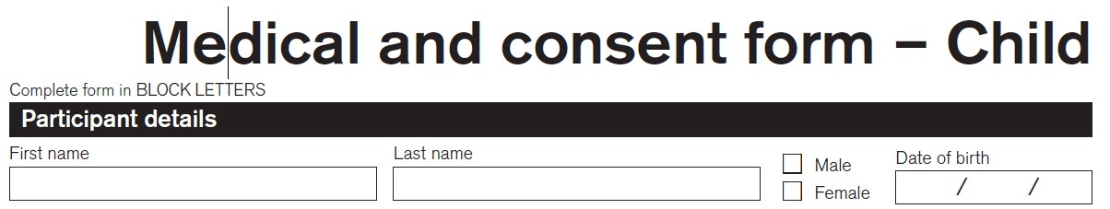

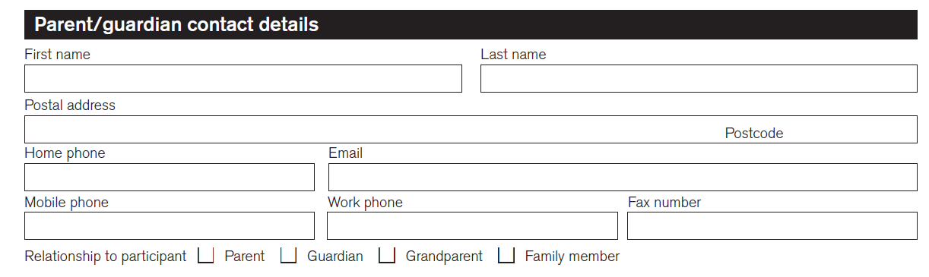

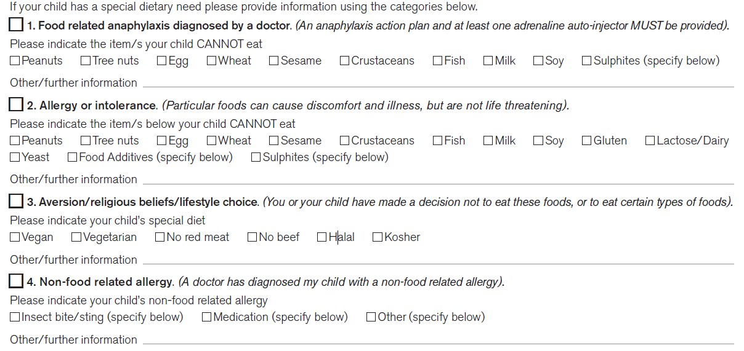

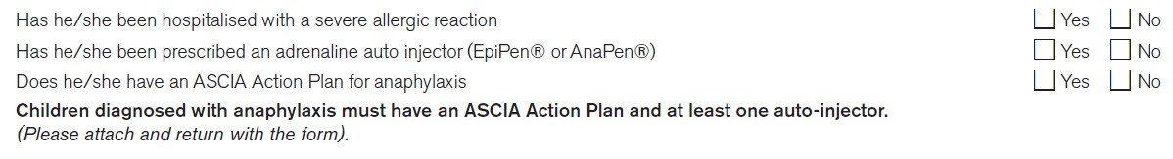

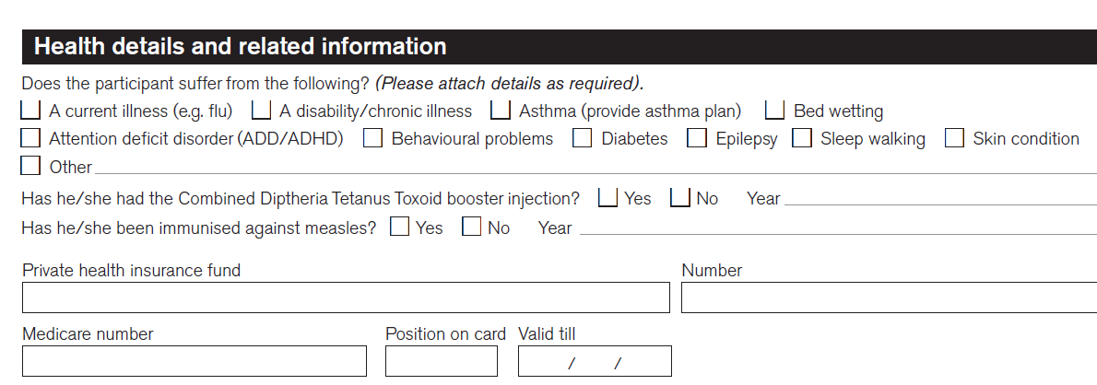

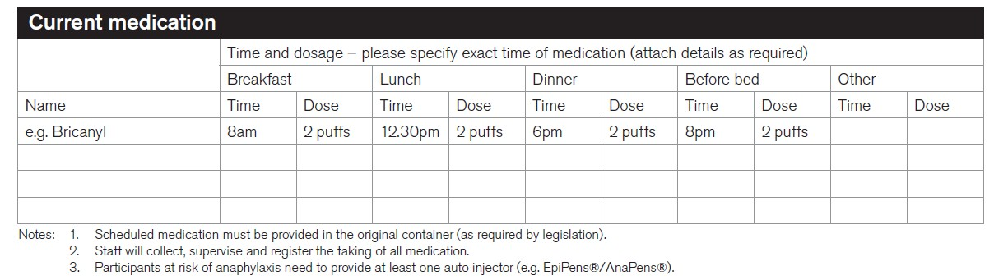
Parental Consent - Stage 2 Berry Excursion, 20 to 21 May, 2019

CONSENT TO MEDICAL ATTENTION
Where the teacher in charge of the excursion is unable to contact me, or it is otherwise impracticable to contact me, I authorise the teacher-in-charge to:
- consent to my child receiving such medical or surgical attention as may be deemed necessary by a medical practitioner
- administer such first aid as the teacher-in-charge may judge to be reasonably necessary, including Panadol.

Signature of Parent/Carer:
Date:

CONSENT TO PARTICIPATE IN THE BERRY OVERNIGHT EXCURSION

I am aware of the program and type of activities that my child shall be participating in, and hereby give consent for my child, to attend the stage two Berry overnight/2 day excursion from the 20 and 21 May, 2019.

I am aware my child will be travelling by bus and sleeping for one night at the Sports and Recreation Centre in Berry. Students will be supervised by Mrs Bajic, Mrs Athanasiou, Miss Philp, Mr Delaney, Miss Goslinga and Miss Kapellos.

Signature of Parent/Carer:
Date:

